S.NO. | DESCRIPTION | PAGE NO.
1 | INTRODUCTION  1.1 ORGANIZATION PROFILE  1.2 SYSTEM SPECIFICATION  1.2.1 HARDWARE REQUIREMENTS  1.2.2 SOFTWARE REQUIREMENTS
2 | SYSTEM STUDY  2.1 EXISTING SYSTEM  2.1.1 DRAWBACKS  2.2 PROPOSED SYSTEM  2.2.1 FEATURES
3 | SYSTEM DESIGN AND DEVELOPMENT  3.1 FILE DESIGN  3.2 INPUT DESIGN  3.3 CODE DESIGN  3.4 OUTPUT DESIGN  3.5 DATABASE DESIGN  3.6 SYSTEM DEVELOPMENT  3.6.1 MODULES  3.6.2 MODULES DESCRIPTION
4 | TESTING AND IMPLEMENTATION
5 | FESIBILIY STUDY
6 | CONCLUSION  BIBLIOGRAPHY
7 | APPENDIX  A. SYSTEM ARCHITECTURE  B. TABLE STRUCTURE  C. SAMPLE SOURCE CODE  D. SAMPLE INPUT  E. SAMPLE OUTPUT
CONTENT

SYNOPSIS

SYNOPSIS
In this paper, we introduce a new fine-grained two-factor authentication (2FA) access control system for web-based cloud computing services. Specifically, in our proposed 2FA access control system, an attribute-based access control mechanism is implemented with the necessity of both a user secret key and a lightweight security device. As a user cannot access the system if they do not hold both, the mechanism can enhance the security of the system, especially in those scenarios where many users share the same computer for web-based cloud services. In addition, attribute-based control in the system also enables the cloud server to restrict the access to those users with the same set of attributes while preserving user privacy, i.e., the cloud server only knows that the user fulfills the required predicate, but has no idea on the exact identity of the user. Finally, we also carry out a simulation to demonstrate the practicability of our proposed 2FA system.
.

INTRODUCTION

INTRODUCTION
  - OVERVIEW
Information security, sometimes shortened to InfoSec, is the practice of preventing unauthorized access, use, disclosure, disruption, modification, inspection, recording or destruction of information. It is a general term that can be used regardless of the form the data may take (e.g. electronic, physical).
1.2 IT SECURITY
Sometimes referred to as computer security, information technology security is information security applied to technology (most often some form of computer system). It is worthwhile to note that a computer does not necessarily mean a home desktop. A computer is any device with a processor and some memory. Such devices can range from non-networked standalone devices as simple as calculators, to networked mobile computing devices such as smartphones and tablet computers. IT security specialists are almost always found in any major enterprise/establishment due to the nature and value of the data within larger businesses. They are responsible for keeping all of the technology within the company secure from malicious cyber attacks that often attempt to breach into critical private information or gain control of the internal systems.
1.3 INFORMATION ASSURANCE
The act of providing trust of the information, that the Confidentiality, Integrity and Availability (CIA) of the information are not violated. E.g., ensuring that data is not lost when critical issues arise. These issues include, but are not limited to: natural disasters, computer/server malfunction or physical theft. Since most information is stored on computers in our modern era, information assurance is typically dealt with by IT security specialists. A common method of providing information assurance is to have an off-site backup of the data in case one of the mentioned issues arise.

1.4 THREATS
Information security threats come in many different forms. Some of the most common threats today are software attacks, theft of intellectual property, identity theft, theft of equipment or information, sabotage, and information extortion. Most people have experienced software attacks of some sort. Viruses,^{[2]} worms, phishing attacks, and Trojan horses are a few common examples of software attacks. The theft of intellectual property has also been an extensive issue for many businesses in the IT field. Identity theft is the attempt to act as someone else usually to obtain that person's personal information or to take advantage of their access to vital information. Theft of equipment or information is becoming more prevalent today due to the fact that most devices today are mobile. Cell phones are prone to theft, and have also become far more desirable as the amount of data capacity increases.
Sabotage usually consists of the destruction of an organization′s websitein an attempt to cause loss of confidence on the part of its customers. Information extortion consists of theft of a company′s property or information as an attempt to receive a payment in exchange for returning the information or property back to its owner, as with ransomware. There are many ways to help protect yourself from some of these attacks but one of the most functional precautions is user carefulness.
Governments, military, corporations, financialinstitutions, hospitals and private businesses amass a great deal of confidential information about their employees, customers, products, research and financial status. Most of this information is now collected, processed and stored on electronic computers and transmitted across networks to other computers.
Should confidential information about a business' customers or finances or new product line fall into the hands of a competitor or a black hat hacker, a business and its customers could suffer widespread, irreparable financial loss, as well as damage to the company's reputation. From a business perspective, information security must be balanced against cost; the Gordon-Loeb Model provides a mathematical economic approach for addressing this concern.^{[3]} For the individual, information security has a significant effect on privacy, which is viewed very differently in different cultures.
The field of information security has grown and evolved significantly in recent years. It offers many areas for specialization, including securing networks and allied infrastructure, securing applications and databases, security testing, information systems auditing, business continuity planning and digital forensics.
1.5 RESPONSES TO THREATS:
Possible responses to a security threat or risk are:
- reduce/mitigate - implement safeguards and countermeasures to eliminate vulnerabilities or block threats
- assign/transfer - place the cost of the it onto another entity or organization such as purchasing insurance or outsourcing
- accept - evaluate if cost of countermeasure outweighs the possible cost of loss due to threat
- ignore/reject - not a valid or prudent due-care response

1.2 SYSTEM SPECIFICATION

1.2.1 HARDWARE REQUIREMENTS:

Processor - Intel Core i3
  - Speed - 2.3 GHz
  - RAM - 4 GB
  - Hard Disk - 500 GB
  - Key Board - Standard Windows Keyboard
  - Mouse - Three Button Mouse
  - Monitor - 17” LED

1.2.2 SOFTWARE REQUIREMENTS:

- Operating System : Windows 10
- Front End : Jdk1.6 , Java Server Pages (JSP)
- Server : Tomcat Server 6.8
- Database : MySQL Server 5.5
- Database Connectivity : JDBC.

SOFTWARE ENVIRONMENT
JAVA:
Java is a programming language created by James Gosling from Sun Microsystems (Sun) in 1991. The target of Java is to write a program once and then run this program on multiple operating systems.
The first publicly available version of Java (Java 1.0) was released in 1995. Sun Microsystems was acquired by the Oracle Corporation in 2010. Oracle has now the steermanship for Java. In 2006 Sun started to make Java available under the GNU General Public License (GPL). Oracle continues this project called Open JDK.
PLATFORM INDEPENDENT
Unlike many other programming languages including C and C++ when Java is compiled, it is not compiled into platform specific machine, rather into platform independent byte code. This byte code is distributed over the web and interpreted by virtual Machine (JVM) on whichever platform it is being run.
JAVA VIRTUAL MACHINE
Java was designed with a concept of ‘write once and run everywhere’. Java Virtual Machine plays the central role in this concept. The JVM is the environment in which Java programs execute. It is software that is implemented on top of real hardware and operating system. When the source code (.java files) is compiled, it is translated into byte codes and then placed into (.class) files. The JVM executes these byte codes.
So Java byte codes can be thought of as the machine language of the JVM. A JVM can either interpret the byte code one instruction at a time or the byte code can be compiled further for the real microprocessor using what is called a just-in-time compiler. The JVM must be implemented on a particular platform before compiled programs can run on that platform.

JAVA DEVELOPMENT KIT
The Java Development Kit (JDK) is a Sun product aimed at Java developers. Since the introduction of Java, it has been by far the most widely used Java software development kit (SDK). It contains a Java compiler, a full copy of the Java Runtime Environment (JRE), and many other important development tools.
TOOLS
You will need a Pentium 200-MHz computer with a minimum of 64 MB of RAM (128 MB of RAM recommended).
You will also need the following softwares:
- Linux 7.1 or Windows xp/7/8 operating system
- Java JDK 8
- Microsoft Notepad or any other text editor
FEATURES
- Reusability of Code
- Emphasis on data rather than procedure
- Data is hidden and cannot be accessed by external functions
- Objects can communicate with each other through functions
- New data and functions can be easily added

A Java web application generates interactive web pages containing various types of markup language (HTML, XML, and so on) and dynamic content. It is typically comprised of web components such as Java Server Pages (JSP), Servlets and JavaBeans to modify and temporarily store data, interact with databases and web services, and render content in response to client requests.
Because many of the tasks involved in web application development can be repetitive or require a surplus of boilerplate code, web frameworks can be applied to alleviate the overhead associated with common activities. For example, many frameworks, such as Java Server Faces, provide libraries for templating pages and session management, and often promote code reuse.

Java EE (Enterprise Edition) is a widely used platform containing a set of coordinated technologies that significantly reduce the cost and complexity of developing, deploying, and managing multi-tier, server-centric applications. Java EE builds upon the Java SE platform and provides a set of APIs (application programming interfaces) for developing and running portable, robust, scalable, reliable and secure server-side applications.

Some of the fundamental components of Java EE include:
- Enterprise JavaBeans (EJB): a managed, server-side component architecture used to encapsulate the business logic of an application. EJB technology enables rapid and simplified development of distributed, transactional, secure and portable applications based on Java technology.
- Java Persistence API (JPA): a framework that allows developers to manage data using object-relational mapping (ORM) in applications built on the Java Platform.

JavaScript and Ajax Development
JavaScript is an object-oriented scripting language primarily used in client-side interfaces for web applications. Ajax (Asynchronous JavaScript and XML) is a Web 2.0 technique that allows changes to occur in a web page without the need to perform a page refresh. JavaScript toolkits can be leveraged to implement Ajax-enabled components and functionality in web pages.

Web Server and Client
Web Server is software that can process the client request and send the response back to the client. For example, Apache is one of the most widely used web server. Web Server runs on some physical machine and listens to client request on specific port.
A web client is software that helps in communicating with the server. Some of the most widely used web clients are Firefox, Google Chrome, Safari etc. When we request something from server (through URL), web client takes care of creating a request and sending it to server and then parsing the server response and present it to the user.

HTML and HTTP
Web Server and Web Client are two separate softwares, so there should be some common language for communication. HTML is the common language between server and client and stands for HyperText Markup Language.
Web server and client needs a common communication protocol, HTTP (HyperText Transfer Protocol) is the communication protocol between server and client. HTTP runs on top of TCP/IP communication protocol.

HTTP Method – action to be performed, usually GET, POST, PUT etc.
- URL – Page to access
- Form Parameters – similar to arguments in a java method, for example user, password details from login page

Sample HTTP Request:
- GET /FirstServletProject/jsps/hello.jsp HTTP/1.1
- Host: localhost:8080
3.Cache-Control: no-cache
Some of the important parts of HTTP Response are:
- Status Code – an integer to indicate whether the request was success or not. Some of the well known status codes are 200 for success, 404 for Not Found and 403 for Access Forbidden.
- Content Type – text, html, image, pdf etc. Also known as MIME type
- Content – actual data that is rendered by client and shown to user.
Web Container
Tomcat is a web container, when a request is made from Client to web server, it passes the request to web container and it’s web container job to find the correct resource to handle the request (servlet or JSP) and then use the response from the resource to generate the response and provide it to web server. Then web server sends the response back to the client. When web container gets the request and if it’s for servlet then container creates two Objects HTTPServletRequest and HTTPServletResponse. Then it finds the correct servlet based on the URL and creates a thread for the request. Then it invokes the servlet service() method and based on the HTTP method service() method invokes doGet() or doPost() methods. Servlet methods generate the dynamic page and write it to response. Once servlet thread is complete, container converts the response to HTTP response and sends it back to client.

- Communication Support – Container provides easy way of communication between web server and the Servlets and JSPs. Because of container, we don’t need to build a server socket to listen for any request from web server, parse the request and generate response.
- Lifecycle and Resource Management – Container takes care of managing the life cycle of servlet. Container takes care of loading the Servlets into memory, initializing Servlets, invoking servlet methods and destroying them.
- Multithreading Support – Container creates new thread for every request to the servlet and when it’s processed the thread dies. So Servlets are not initialized for each request and saves time and memory.
- JSP Support – JSPs doesn’t look like normal java classes and web container provides support for JSP. Every JSP in the application is compiled by container and converted to Servlet and then container manages them like other Servlets.
- Miscellaneous Task – Web container manages the resource pool, does memory optimizations, run garbage collector, and provides security configurations, support for multiple applications, hot deployment and several other tasks behind the scene that makes our life easier.

SYSTEM STUDY

2. SYSTEM STUDY

2.1 EXISTING SYSTEM

Though the new paradigm of cloud computing provides great advantages, there are meanwhile also concerns about security and privacy especially for web-based cloud services. As sensitive data may be stored in the cloud for sharing purpose or convenient access; and eligible users may also access the cloud system for various applications and services, user authentication has become a critical component for any cloud system. A user is required to login before using the cloud services or accessing the sensitive data stored in the cloud. There are two problems for the traditional account/passwordbased system.

2.1.1 DISADVANTAGES
- First, the traditional account/password-based authentication is not privacy-preserving. However, it is well acknowledged that privacy is an essential feature that must be considered in cloud computing systems.
- Second, it is common to share a computer among different people. It may be easy for hackers to install some spyware to learn the login password from the web-browser.
- In existing, Even though the computer may be locked by a password, it can still be possibly guessed or stolen by undetected malwares.
2.2 PROPOSED SYSTEM
In this paper, we propose a fine-grained two-factor access control protocol for web-based cloud computing services, using a lightweight security device. The device has the following properties: (1) it can compute some lightweight algorithms, e.g. hashing and exponentiation; and (2) it is tamper resistant, i.e., it is assumed that no one can break into it to get the secret information stored inside.

    - ADVANTAGES
- protocol provides a 2FA security

3. SYSTEM DESIGN AND DEVELOPMENT

3.1 FILE DESIGN

When large volumes of data are being handled, it’s important that the items to be stored are selected easily and quickly. To accomplish this each data item must have a unique specification and must be related to other forms or items of data of the same type. The master file transaction is related to the same type id in the other table while using the primary key in p-id. A master file in product id is related to another table. There are various product id numbers in the various numbers in the various numbers of products.
The purpose of codes is to facilitate the identification and retrieval of items of information. The system analysts will find code structures will not always be the most suitable for efficient computer processing principles of code design. To accomplish this, each data item must have a unique identification and must be related to the other items of data of the data and same data type.
3.2 INPUT DESIGN

The input design is the link between the information system and the user. It comprises the developing specification and procedures for data preparation and those steps are necessary to put transaction data in to a usable form for processing can be achieved by inspecting the computer to read data from a written or printed document or it can occur by having people keying the data directly into the system. The design of input focuses on controlling the amount of input required, controlling the errors, avoiding delay, avoiding extra steps and keeping the process simple. The input is designed in such a way so that it provides security and ease of use with retaining the privacy. Input Design considered the following things:’
- What data should be given as input?
- How the data should be arranged or coded?
- The dialog to guide the operating personnel in providing input.
OBJECTIVES
1.Input Design is the process of converting a user-oriented description of the input into a computer-based system. This design is important to avoid errors in the data input process and show the correct direction to the management for getting correct information from the computerized system.
2.It is achieved by creating user-friendly screens for the data entry to handle large volume of data. The goal of designing input is to make data entry easier and to be free from errors. The data entry screen is designed in such a way that all the data manipulates can be performed. It also provides record viewing facilities.
3.When the data is entered it will check for its validity. Data can be entered with the help of screens. Appropriate messages are provided as when needed so that the user
will not be in maize of instant. Thus the objective of input design is to create an input layout that is easy to follow.
3.3 CODE DESIGN
This overview section contains a list of each table and their relationships with each other – brief and general. I would like to have a graphic showing the links, similar to what Dave did in the PowerPoint slides.
The STEWARDS data management system contains three components. They are the CEAP watershed measurement data, the ARS Methods Catalog, and the STEWARDS System Support data files.
The CEAP watershed measurement data are located in a suite of data table pairs (Data table and Data Definition table). The tables are assembled and populated by watershed personnel. Watershed data will be managed as a collection sites with a common theme as derived from individual measurement devices, i.e., South Fork Meteorology - Temperature, rainfall, atmospheric pressure, wind. Site measurement data will be managed by unique SiteID/DateTime pairs, with measurements as additional column headings using generic column names mapped to detailed information in the Definition tableThe tables include:
- Code design – These tables contain the watershed’s measurement data and are described by the Data Table Definition.
- Data Table Definition Table – This table describes all the measurement code design provided by the watersheds. The Definition table will maintain the relationship between the data producer’s data-table specific column names and the ARS Methods Catalog.

The ARS Methods Catalog contains essential information to explain the characteristics of the measurement data. The tables provide users information to accurately understand the measurements. The table values are populated by watershed data producers assisted by a science review committee. The Methods Catalog is currently housed as a MS Access code design and is accompanied by a suite of tools that may be used to populate the Methods table, Analyte table, and the Parameter table. These tables include:
- Parameter Table – This is the key table for user querying data using a topic.
- Methods Table – The table captures information describing general and detailed methods the watershed used to obtain the measurement data. The tables also include

- Sites table – This table links the sites which the data are collected with the tables that hold the measurement data.
- SourceTables table – describes the individual measurement code design (TableID ) with table name, time step, theme, location identifier, date of the last update, andtable author.
- Locations table – This table provide information about the location (watershed) where the measurement data are collected.
- DataTable-to-Shapefile table – A table that links shapefiles with their associated code design. In the case of multiple time-steps for a measurement theme, there may be more than one data table associated with a single shapefile.
- Data Download log – A list of downloaded data and the downloader information.

3.4 OUTPUT DESIGN
A quality output is one, which meets the requirements of the end user and presents the information clearly. In any system results of processing are communicated to the users and to other system through outputs. In output design it is determined how the information is to be displaced for immediate need and also the hard copy output. It is the most important and direct source information to the user. Efficient and intelligent output design improves the system’s relationship to help user decision-making.
1. Designing computer output should proceed in an organized, well thought out manner; the right output must be developed while ensuring that each output element is designed so that people will find the system can use easily and effectively. When analysis design computer output, they should Identify the specific output that is needed to meet the requirements.
2.Select methods for presenting information.
3.Create document, report, or other formats that contain information produced by the system.
The output form of an information system should accomplish one or more of the following objectives.
- Convey information about past activities, current status or projections of the
- Future.
- Signal important events, opportunities, problems, or warnings.
- Trigger an action.
- Confirm an action.

3.5 DATABASE DESIGN
Data Constraints
All business in the world runs on business data being gathered stored and analyzed. Business managers determine a set of rules that must be applied to the data being stored to ensure its integrity.
Types of Data Constraints
There are two types of data constraints that can be applied to data being inserted into a database table. One type of constraint is called an I/O constraint. The other type of constraint is called a business rule constraint.
- I/O Constraints:
The input /output data constraint is further divided into two distinctly different constraints.
a)The Primary Key Constraint –
Here the data constraint attached to a column ensures:
- The data entered in the table column is unique across the entire column.
- That none of the cells belonging to the table column are left empty.
b) The Foreign Key Constraint -
Foreign constraint establishes a relationship between records across a master and a detail table. The relationship ensures.
- Records cannot be inserted in a detail table if corresponding records in the master table does not exist.
- Records of the master table cannot be deleted if corresponding records in the detail table exist.
- Business Rule Constraints:
The Database allows the application of business rules to table columns. Business managers determine business rules.
The Database allows programmers to define constraints at:
- Column Level
- Table Level
a)Column Level Constraints
If data constraints are defined along with the column definition where creating or altering a table structure, they are column level constraints.
b) Table Level Constraints
If data constraints are defined after defining all the table columns when creating or altering a table structure, it is a table level constraint.

Null Value Concepts
A NULL value is different from a blank of zero. NULL values are treated specially by the database. A NULL value can be inserted into the columns of any data type.
Not Null Constraint Defined at the Column Level
When a column is defined as not null, then that column becomes a mandatory column .It implies that a value must be entered into the column if the record is to be accepted for storage in the table.
The Primary Key Constraint
A primary key in a table used to uniquely identify each row in the table.A primary key column in a table has special attributes.
It defines the column as a mandatory column i.e. the column cannot be left blank. The NOT NULL attribute is active.
a) All instances will be updated in the database and shows the hackers no. Of attempts…

SYSTEM DEVELOPMENT

3.6. SYSTEM DEVELOPMENT

IMPLEMENTATION
Implementation is the stage of the project when the theoretical design is turned out into a working system. Thus it can be considered to be the most critical stage in achieving a successful new system and in giving the user, confidence that the new system will work and be effective.
The implementation stage involves careful planning, investigation of the existing system and it’s constraints on implementation, designing of methods to achieve changeover and evaluation of changeover methods.
4.1 MODULES:
A module is a part of a program. Programs are composed of one or more independently developed modules that are not combined until the program is linked. A single module can contain one or several routines.
Our project modules are given below:
- Trustee Module
- Attribute-Issuing Authority Module
- User Module
- Cloud Service Provider Module

TRUSTEE:
It is responsible for generating all system parameters and initializes the security device.
ATTRIBUTE-ISSUING AUTHORITY:
It is responsible to generate user secret key for each user according to their attributes.
USER:
- It is the player that makes authentication with the cloud server. Each user has a secret key issued by the attribute-issuing authority and a security device initialized by the trustee.

CLOUD SERVICE PROVIDER:
- It provides services to anonymous authorized users. It interacts with the user during the authentication process.

TESTING AND IMPLEMENTATION

4. TESTING AND IMPLEMENTATION

4.1 SYSTEM TESTING
The purpose of testing is to discover errors. Testing is the process of trying to discover every conceivable fault or weakness in a work product. It provides a way to check the functionality of components, sub assemblies, assemblies and/or a finished product It is the process of exercising software with the intent of ensuring that the Software system meets its requirements and user expectations and does not fail in an unacceptable manner. There are various types of test. Each test type addresses a specific testing requirement.
TYPES OF TESTS:
4.1.1 Unit Testing:
Unit testing involves the design of test cases that validate that the internal program logic is functioning properly, and that program inputs produce valid outputs. All decision branches and internal code flow should be validated. It is the testing of individual software units of the application .it is done after the completion of an individual unit before integration.
This is a structural testing, that relies on knowledge of its construction and is invasive. Unit tests perform basic tests at component level and test a specific business process, application, and/or system configuration. Unit tests ensure that each unique path of a business process performs accurately to the documented specifications and contains clearly defined inputs and expected results.
4.1.2 Integration Testing:
Integration tests are designed to test integrated software components to determine if they actually run as one program. Testing is event driven and is more concerned with the basic outcome of screens or fields. Integration tests demonstrate that although the components were individually satisfaction, as shown by successfully unit testing, the combination of components is correct and consistent. Integration testing is specifically aimed at exposing the problems that arise from the combination of components.
4.1.3 Functional Test:
Functional tests provide systematic demonstrations that functions tested are available as specified by the business and technical requirements, system documentation.
Invalid Input : identified classes of invalid input must be rejected.
Functions : identified functions must be exercised.
Output : identified classes of application outputs must be exercised.
Systems/ Procedures: interfacing systems or procedures must be invoked. Organization and preparation of functional tests is focused on requirements, key functions, or special test cases. In addition, systematic coverage pertaining to identify Business process flows; data fields, predefined processes, and successive processes must be considered for testing. Before functional testing is complete, additional tests are identified and the effective value of current tests is determined.
SYSTEM TEST:
System testing ensures that the entire integrated software system meets requirements. It tests a configuration to ensure known and predictable results. An example of system testing is the configuration oriented system integration test. System testing is based on process descriptions and flows, emphasizing pre-driven process links and integration points.
WHITE BOX TESTING:
White Box Testing is a testing in which in which the software tester has knowledge of the inner workings, structure and language of the software, or at least its purpose. It is purpose. It is used to test areas that cannot be reached from a black box level.
BLACK BOX TESTING:
Black Box Testing is testing the software without any knowledge of the inner workings, structure or language of the module being tested. Black box tests, as most other kinds of tests, must be written from a definitive source document, such as specification or requirements document, such as specification or requirements document. It is a testing in which the software under test is treated, as a black box .you cannot “see” into it. The test provides inputs and responds to outputs without considering how the software works.
UNIT TESTING:
Unit testing is usually conducted as part of a combined code and unit test phase of the software lifecycle, although it is not uncommon for coding and unit testing to be conducted as two distinct phases.
Test strategy and approach
Field testing will be performed manually and functional tests will be written in detail.
Test objectives
- All field entries must work properly.
- Pages must be activated from the identified link.
- The entry screen, messages and responses must not be delayed.

Features to be tested
- Verify that the entries are of the correct format
- No duplicate entries should be allowed
- All links should take the user to the correct page.

4.1.4 Acceptance Testing:
User Acceptance Testing is a critical phase of any project and requires significant participation by the end user. It also ensures that the system meets the functional requirements.
Test Results: All the test cases mentioned above passed successfully. No defects encountered

FEASIBILITY STUDY
5. FEASIBILITY STUDY
The feasibility of the project is analyzed in this phase and business proposal is put forth with a very general plan for the project and some cost estimates. During system analysis the feasibility study of the proposed system is to be carried out. This is to ensure that the proposed system is not a burden to the company. For feasibility analysis, some understanding of the major requirements for the system is essential.
Three key considerations involved in the feasibility analysis are
- Economical feasibility
- Technical feasibility
- Social feasibility
5.1 ECONOMICAL FEASIBILITY:
This study is carried out to check the economic impact that the system will have on the organization. The amount of fund that the company can pour into the research and development of the system is limited. The expenditures must be justified. Thus the developed system as well within the budget and this was achieved because most of the technologies used are freely available. Only the customized products had to be purchased.

5.2 TECHNICAL FEASIBILITY:

This study is carried out to check the technical feasibility, that is, the technical requirements of the system. Any system developed must not have a high demand on the available technical resources. This will lead to high demands on the available technical resources. This will lead to high demands being placed on the client. The developed system must have a modest requirement, as only minimal or null changes are required for implementing this system.
5.3 SOCIAL FEASIBILITY:
The aspect of study is to check the level of acceptance of the system by the user. This includes the process of training the user to use the system efficiently. The user must not feel threatened by the system, instead must accept it as a necessity. The level of acceptance by the

CONCLUSION

6. CONCLUSION

In this paper, we have presented a new 2FA (including both user secret key and a lightweight security device) access control system for web-based cloud computing
services. Based on the attribute-based access control mechanism, the proposed 2FA access control system has been identified to not only enable the cloud server to
restrict the access to those users with the same set of attributes but also preserve user privacy. Detailed security analysis shows that the proposed 2FA access control system achieves the desired security requirements. Through performance evaluation, we demonstrated that the construction is “feasible”. We leave as future work to further improve the efficiency while keeping all nice features of the system.

BIBLIOGRAPHY

[1] M. H. Au and A. Kapadia. PERM: practical reputation-based blacklisting without TTPS. In T. Yu, G. Danezis, and V. D. Gligor, editors, the ACM Conference on Computer and Communications Security, CCS’12, Raleigh, NC, USA, October 16-18, 2012, pages 929– 940. ACM, 2012.
[2] M. H. Au, A. Kapadia, and W. Susilo. Blacr: Ttp-free blacklistable anonymous credentials with reputation. In NDSS. The Internet Society, 2012.
[3] M. H. Au, W. Susilo, and Y. Mu. Constant-Size Dynamic k-TAA. In SCN, volume 4116 of Lecture Notes in Computer Science, pages 111–125. Springer, 2006.
[4] J. Baek, Q. H. Vu, J. K. Liu, X. Huang, and Y. Xiang. A secure cloud computing based framework for big data information management of smart grid. IEEE T. Cloud Computing, 3(2):233–244, 2015.
[5] M. Bellare and O. Goldreich. On defining proofs of knowledge. In CRYPTO, volume 740 of Lecture Notes in Computer Science, pages 390–420. Springer, 1992.
[6] J. Bethencourt, A. Sahai, and B. Waters. Ciphertext-policy attribute-based encryption. In IEEE Symposium on Security and Privacy, pages 321–334. IEEE Computer Society, 2007.
[7] D. Boneh, X. Boyen, and H. Shacham. Short Group Signatures. In Franklin [19], pages 41–55.
[8] D. Boneh, X. Ding, and G. Tsudik. Fine-grained control of security capabilities. ACM Trans. Internet Techn., 4(1):60–82, 2004.
[9] J. Camenisch. Group Signature Schemes and Payment Systems Based on the Discrete Logarithm Problem. PhD thesis, ETH Zurich, 1998. Reprint as vol. 2 of ETH Series in Information Security and Cryptography, ISBN 3-89649-286-1, Hartung-Gorre Verlag, Konstanz, 1998.
[10] J. Camenisch, M. Dubovitskaya, and G. Neven. Oblivious transfer with access control. In E. Al-Shaer, S. Jha, and A. D. Keromytis, editors, Proceedings of the 2009 ACM Conference on Computer and Communications Security, CCS 2009, Chicago, Illinois, USA, November 9-13, 2009, pages 131–140. ACM, 2009.
[11] J. Camenisch and A. Lysyanskaya. A signature scheme with efficient protocols. In S. Cimato, C. Galdi, and G. Persiano, editors, Security in Communication Networks, Third International Conference, SCN 2002, Amalfi, Italy, September 11-13, 2002. Revised Papers, volume 2576 of Lecture Notes in Computer Science, pages
268–289. Springer, 2002.
[12] J. Camenisch and A. Lysyanskaya. Signature Schemes and Anonymous Credentials from Bilinear Maps. In Franklin [19], pages 56–72.
[13] Y. Chen, Z. L. Jiang, S. Yiu, J. K. Liu, M. H. Au, and X. Wang. Fully secure ciphertext-policy attribute based encryption with security mediator. In ICICS ‘14, volume 8958 of Lecture Notes in Computer Science, pages 274–289. Springer, 2014.
[14] S. S. M. Chow, C. Boyd, and J. M. G. Nieto. Security-mediated certificateless cryptography. In Public Key Cryptography, volume 3958 of Lecture Notes in Computer Science, pages 508–524. Springer, 2006.
[15] C. Chu, W. T. Zhu, J. Han, J. K. Liu, J. Xu, and J. Zhou. Security concerns in popular cloud storage services. IEEE Pervasive Computing, 12(4):50–57, 2013.

APPENDICES

6. APPENDICES

SYSTEM ARCHITECTURE

CLASS DIAGRAM
ACTIVITY DIAGRAM

SEQUENCE DIAGRAM:

TABLE DESIGN
CLOUD STORAGE:
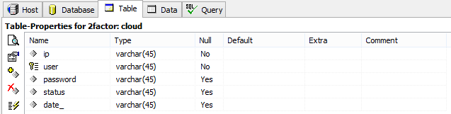

REQUEST TABLE:
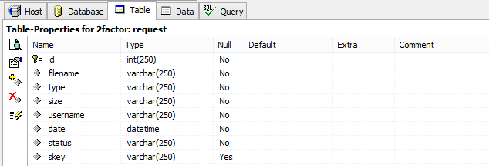
TRANSACTION TABLE:
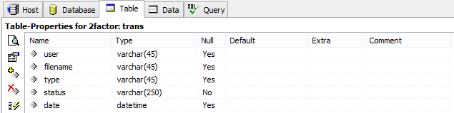

UPLOAD FILES TABLE:
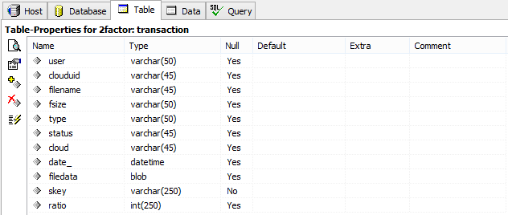

USER REGISTRATION TABLE:
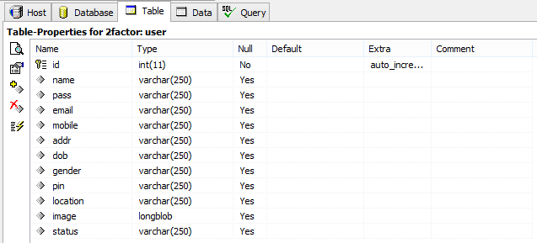

C. SAMPLE SOURCE CODE

USER REGISTRATION:

<%@page import="java.util.UUID"%>
<%@page import="java.net.HttpURLConnection"%>
<%@page import="java.net.URL"%>
<%@page import="java.net.URLEncoder"%>
<%@page import="design.mailsession"%>
<%@page import="java.sql.ResultSet"%>
<%@page import="java.util.Random"%>
<%@page import="java.sql.Statement"%>
<%@page import="java.sql.DriverManager"%>
<%@page import="java.net.InetAddress"%>
<%@page import="java.sql.Connection"%>
<%@page import="com.oreilly.servlet.*,java.sql.*,java.lang.*,java.text.SimpleDateFormat,java.util.*,java.io.*,javax.servlet.*,javax.servlet.http.*" %>
<%@ page import="java.sql.*"%>
<%@ include file="connect.jsp" %>
<%@ page import="java.util.Date" %>

<title>User Register</title>
<%
ArrayList list = new ArrayList();
ServletContext context = getServletContext();
String dirName =context.getRealPath("Gallery/");
String paramname = null;
String uname = "", pass = null, email = null, mobile = null, address = null;
String dob = null, gender = null, pincode = null, location = null, image = null;
File file1 = null;
FileInputStream fs = null, fs1 = null;
String secretkey = UUID.randomUUID().toString();
System.out.println("SESS = " + secretkey);
System.out.println("WEBSITE KEY: "+secretkey);

try {
MultipartRequest multi = new MultipartRequest(request, dirName, 10 * 1024 * 1024); // 10MB
Enumeration params = multi.getParameterNames();
while (params.hasMoreElements()) {
paramname = (String) params.nextElement();

if (paramname.equalsIgnoreCase("userid")) {
uname = multi.getParameter(paramname);
session.setAttribute("name",uname);
//System.out.println(name);

}
if (paramname.equalsIgnoreCase("pswd")) {
pass = multi.getParameter(paramname);
}
if (paramname.equalsIgnoreCase("email")) {
email = multi.getParameter(paramname);
}
if (paramname.equalsIgnoreCase("mobile")) {
mobile = multi.getParameter(paramname);
}
if (paramname.equalsIgnoreCase("address")) {
address = multi.getParameter(paramname);
}
if (paramname.equalsIgnoreCase("dob")) {
dob = multi.getParameter(paramname);
}
if (paramname.equalsIgnoreCase("gender")) {
gender = multi.getParameter(paramname);
}
if (paramname.equalsIgnoreCase("pin")) {
pincode = multi.getParameter(paramname);
}
if (paramname.equalsIgnoreCase("loc")) {
location = multi.getParameter(paramname);
}
if (paramname.equalsIgnoreCase("pic")) {
image = multi.getParameter(paramname);
}
}

int f = 0;
Enumeration files = multi.getFileNames();
while (files.hasMoreElements()) {
paramname = (String) files.nextElement();
if (paramname.equals("d1")) {
paramname = null;
}

if (paramname != null) {
f = 1;
image = multi.getFilesystemName(paramname);
String fPath = context.getRealPath("Gallery\\" + image);
file1 = new File(fPath);
fs = new FileInputStream(file1);
list.add(fs);

String query1 = "SELECT * FROM user WHERE name='"+ uname + "' ";
Statement st1 = connection.createStatement();
ResultSet rs1 = st1.executeQuery(query1);
if (rs1.next()) {
out.print("UserNmae Already Exists");
%>
<p><a href="RegisterS.jsp">Back</a> <a href="index.jsp">Home</a> </p>
<%
} else {
mailsession m=new mailsession();
m.mailsend(secretkey, email);

PreparedStatement ps = connection.prepareStatement("INSERT INTO user(name,pass,email,mobile,addr,dob,gender,pin,location,image,status) values(?,?,?,?,?,?,?,?,?,?,?)");
ps.setString(1, uname);
ps.setString(2, pass);
ps.setString(3, email);
ps.setString(4, mobile);
ps.setString(5, address);
ps.setString(6, dob);
ps.setString(7, gender);
ps.setString(8, pincode);
ps.setString(9, location);
ps.setString(11,secretkey);
if (f == 0)
ps.setObject(10, null);
else if (f == 1) {
fs1 = (FileInputStream) list.get(0);
ps.setBinaryStream(10, fs1, fs1.available());
}
int x = ps.executeUpdate();
if (x > 0) {
out.print("Registered Successfully!!!!");
String suc="Registered Successfully!!!!";
application.setAttribute("msg",suc);
response.sendRedirect("regsuccess.jsp");
%>
<p><a href="regsuccess.jsp">Back</a> <a href="index.jsp">Home</a></p>
<%
}

}

}
}

} catch (Exception e) {
e.printStackTrace();
out.print(e.getMessage());
}
%>

DOWNLOAD FILES:

<%@page import="design.download"%>
<%@page import="java.sql.ResultSet"%>
<%@page import="java.sql.Statement"%>
<%@page import="java.sql.DriverManager"%>
<%@page import="java.sql.Connection"%>
<%
String namee=request.getParameter("file");
String s=request.getParameter("key");
String uname =session.getAttribute("name").toString();
//System.out.println(" user name"+ username);
//System.out.println(" user password"+ password);
Class.forName("com.mysql.jdbc.Driver");
Connection con = DriverManager.getConnection("jdbc:mysql://localhost:3306/2factor","root","root");
Statement st = con.createStatement();
String Q = "select * from request where filename= '"+namee+"' ";
ResultSet rs = st.executeQuery(Q);

if(rs.next()){

if((rs.getString("filename").equals(namee))&&(rs.getString("skey").equals(s))&&(rs.getString("username").equals(uname))){
session.setAttribute("ff", namee);
int i2 = st.executeUpdate("insert into trans (user,filename,type,status,Date)values('"+uname+"','"+namee+"','download','File Downloaded',now())");
response.sendRedirect("userdwn.jsp?ms= sucess..!");
}
else{
Class.forName("com.mysql.jdbc.Driver");
con = DriverManager.getConnection("jdbc:mysql://localhost:3306/2factor", "root", "root");
Statement st2 = con.createStatement();
int i = st2.executeUpdate("insert into trans (user,filename,type,status,Date)values('"+uname+"','"+namee+"','hacked','Attacked Ciphertext Key',now())");
Statement st3 = con.createStatement();
// int j = st3.executeUpdate("UPDATE endur SET status='REVOKED' where uname='"+uname+"'");

// String sql = "insert into hackers (user,filename)values('"+me+"',m'"+namee+"')";
if (i != 0) {

response.sendRedirect("userhome.jsp?msghack=hacker");

}

// response.sendRedirect("userpage.jsp?msgrr= Error found..!");
//out.println("<script>alert('wrong')</script>");
}
}
else{

response.sendRedirect("userpage.jsp?msgrrr= Error found..!");
//out.println("<script>alert('wrong again')</script>");
}

%>
UPLOAD FILES:
/*
* To change this template, choose Tools | Templates
* and open the template in the editor.
*/
package com.Action;

import com.util.*;
import java.io.*;
import java.sql.Connection;
import java.sql.PreparedStatement;
import java.sql.ResultSet;
import java.util.Iterator;
import java.util.List;
import java.util.Random;
import java.util.logging.Level;
import java.util.logging.Logger;
import javax.crypto.Cipher;
import javax.crypto.SecretKey;
import javax.crypto.SecretKeyFactory;
import javax.crypto.spec.PBEKeySpec;
import javax.crypto.spec.PBEParameterSpec;
import javax.servlet.ServletException;
import javax.servlet.http.HttpServlet;
import javax.servlet.http.HttpServletRequest;
import javax.servlet.http.HttpServletResponse;
import org.apache.tomcat.util.http.fileupload.FileItem;
import org.apache.tomcat.util.http.fileupload.disk.DiskFileItemFactory;
import org.apache.tomcat.util.http.fileupload.servlet.ServletFileUpload;

/**
*
* @author Sabari
*/
public class UploadActions extends HttpServlet {

private static final String TMP_DIR_PATH = "c:\\tmp\\";
private File tmpDir;
private static final String DESTINATION_DIR_PATH = "file";
private File destinationDir;

/**
* Processes requests for both HTTP <code>GET</code> and <code>POST</code> methods.
* @param request servlet request
* @param response servlet response
* @throws ServletException if a servlet-specific error occurs
* @throws IOException if an I/O error occurs
*/
protected void processRequest(HttpServletRequest request, HttpServletResponse response)
throws ServletException, IOException {
response.setContentType("text/html;charset=UTF-8");
PrintWriter out = response.getWriter();

DiskFileItemFactory fileItemFactory = new DiskFileItemFactory();
/*
*Set the size threshold, above which content will be stored on disk.
*/
fileItemFactory.setSizeThreshold(1 * 1024 * 1024); //1 MB
/*
* Set the temporary directory to store the uploaded files of size above threshold.
*/
fileItemFactory.setRepository(tmpDir);

ServletFileUpload uploadHandler = new ServletFileUpload(fileItemFactory);
Connection con = null;
PreparedStatement pstm = null;
PreparedStatement pstm1 = null;
PreparedStatement pstm2 = null;
PreparedStatement pstm3 = null;

try {
/*
* Parse the request
*/
con = DbConnector.getConnection();
List items = uploadHandler.parseRequest(request);
Iterator itr = items.iterator();
String fileName = "";
FileItem item = (FileItem) itr.next();
String fName=item.getName();
String fieldName = item.getFieldName();

boolean isInMemory = item.isInMemory();
long sizeInBytes = item.getSize();
String myString = Long.toString(sizeInBytes)+" Bytes";
String type = item.getContentType();
String sql1 = "select * from transaction where filename='" + item.getName() + "' AND type='"+type+"' AND fsize='"+myString+"' OR fsize='"+myString+"' AND type='"+type+"'";
System.out.println(">>>>>>>>>>" + sql1);
pstm = con.prepareStatement(sql1);
ResultSet rs = pstm.executeQuery();
if (rs.next()) {
System.out.println(">>>>>>>>>>>>>>>>>>>>>>>>>>>>.loop");
response.sendRedirect("upload.jsp?msg=Exist");
} else {
fileName = (String) item.getName();
int x=fileName.lastIndexOf('\\');
String fN=fileName.substring(x+1, fileName.length());
String ext=fileName.substring(fileName.lastIndexOf(".") + 1);
System.out.println(fN);

File inFile = new File(Constant.file + fN);
item.write(inFile);
// Encrypt the file before uploading in FTP
File encFile =EncryptionUtil.encrypt(inFile);

// File file = new File(Constant.file, item.getName());
// item.write(file);
// System.out.println("" + file.getAbsolutePath());
SimpleFTPClient client = null;

String sq1 = "select * from cloud where status='Active'";

pstm3 = con.prepareStatement(sq1);
ResultSet rs1 = pstm3.executeQuery();

/**
* Handles the HTTP <code>POST</code> method.
* @param request servlet request
* @param response servlet response
* @throws ServletException if a servlet-specific error occurs
* @throws IOException if an I/O error occurs
*/
@Override
protected void doPost(HttpServletRequest request, HttpServletResponse response)
throws ServletException, IOException {
processRequest(request, response);
}

/**
* Returns a short description of the servlet.
* @return a String containing servlet description
*/
@Override
public String getServletInfo() {
return "Short description";
}// </editor-fold>

}
DATABASE CONNECTION:
package com.util;
/*
* To change this template, choose Tools | Templates
* and open the template in the editor.
*/
public class DbConnector {
// System.out.println("MySQL Connect Example.");

public static Connection getConnection() {
Connection conn = null;
String url = "jdbc:mysql://localhost:3306/";
String dbName = "2factor";
String driver = "com.mysql.jdbc.Driver";
String userName = "root";
String password = "root";
try {
Class.forName(driver).newInstance();
conn = DriverManager.getConnection(url + dbName, userName, password);
System.out.println("Connected to the database");
//conn.close();
//System.out.println("Disconnected from database");
} catch (Exception e) {
e.printStackTrace();
}
return conn;
}

public static void main(String arg[]){
DbConnector.getConnection();
}
}

D. SAMPLE INPUT
HOME PAGE :
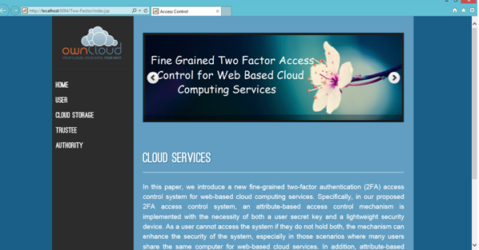

USER REGISTER PAGE :
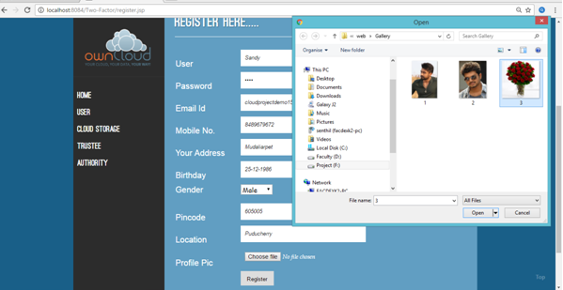

USER LOGIN :
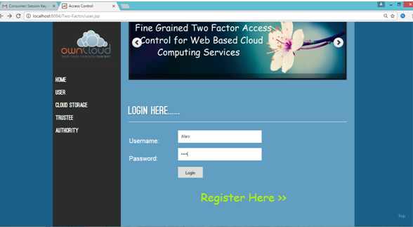

VERIFY OTP :
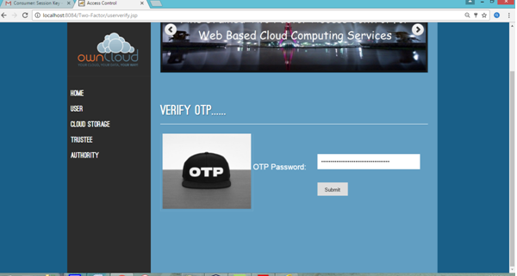

REQUEST FILE
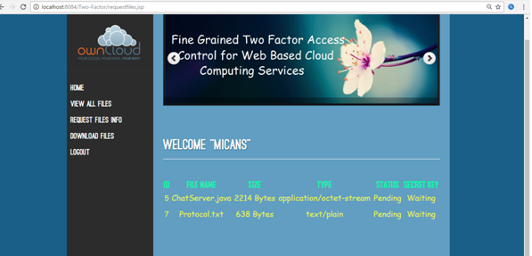

DOWNLOAD FILES :
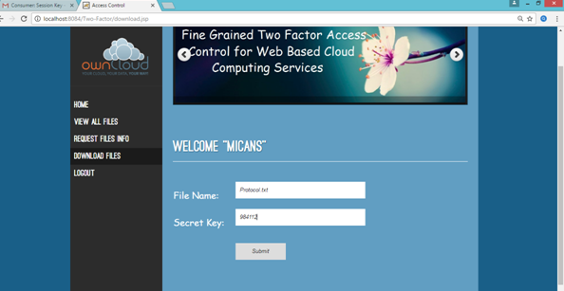

CLOUD LOGIN :
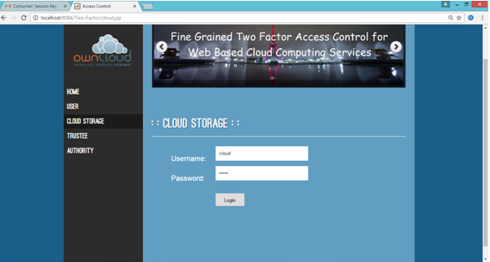

ALL USER :
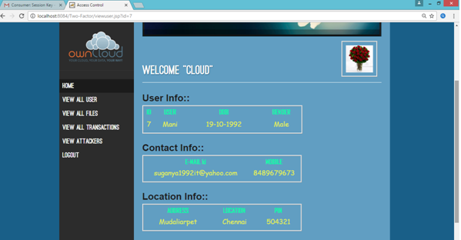

ALL FILES :
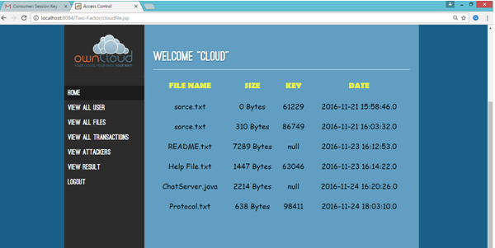

ALL UPLOAD FILES :
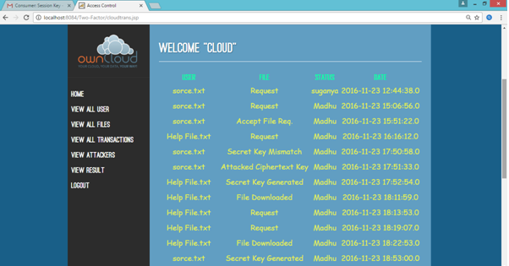

TRANSACTION :
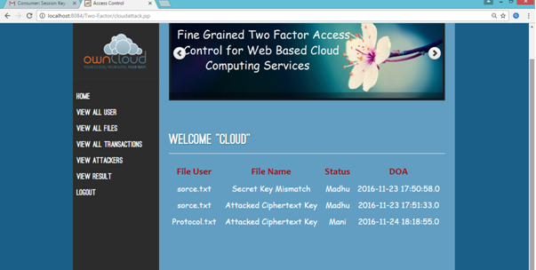

E. SAMPLE OUTPUT
GRAPH :
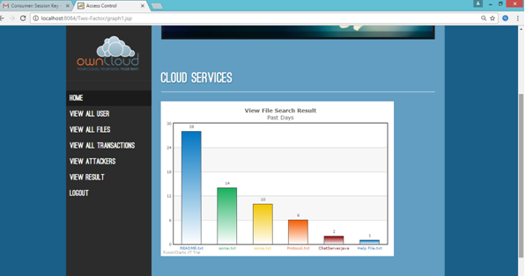

TRUSTEE LOGIN :
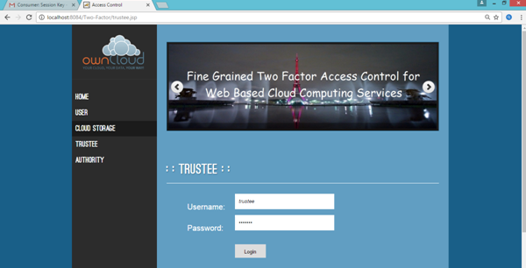

UPLOAD FILES :
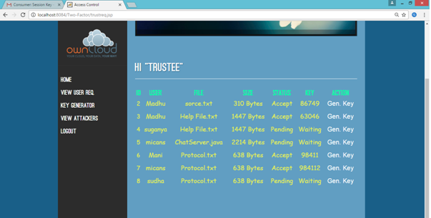

GENERATE KEY :
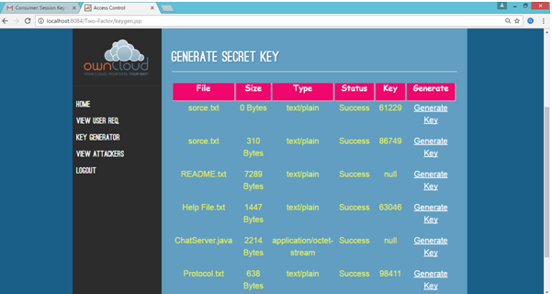

AUTHORITY LOGIN :
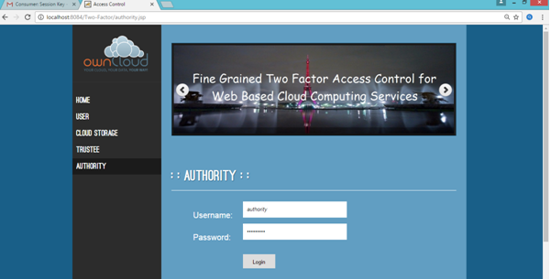

UPLOAD FILE :
